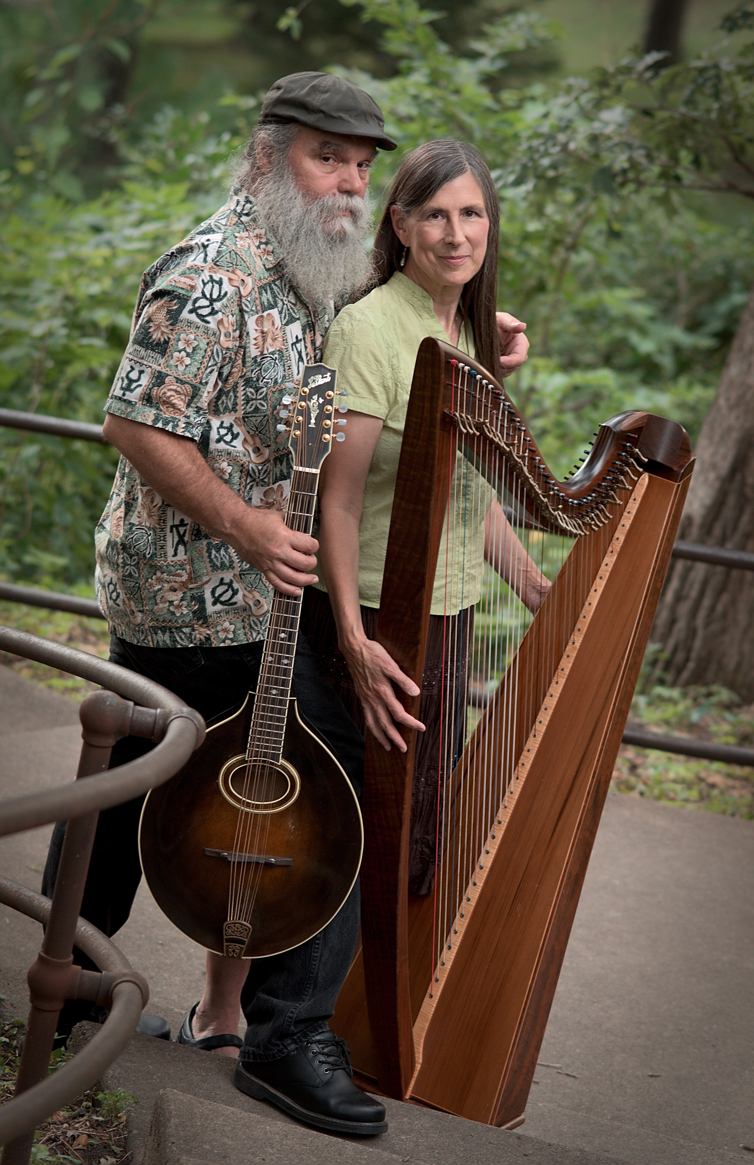

***CURTIS & LORETTA***

**[www.curtisandloretta.com](http://www.curtisandloretta.com)**

**“…they blend humor and realism in a a poignant performance of super-duper stuff.” … Illinois Times, Springfield**