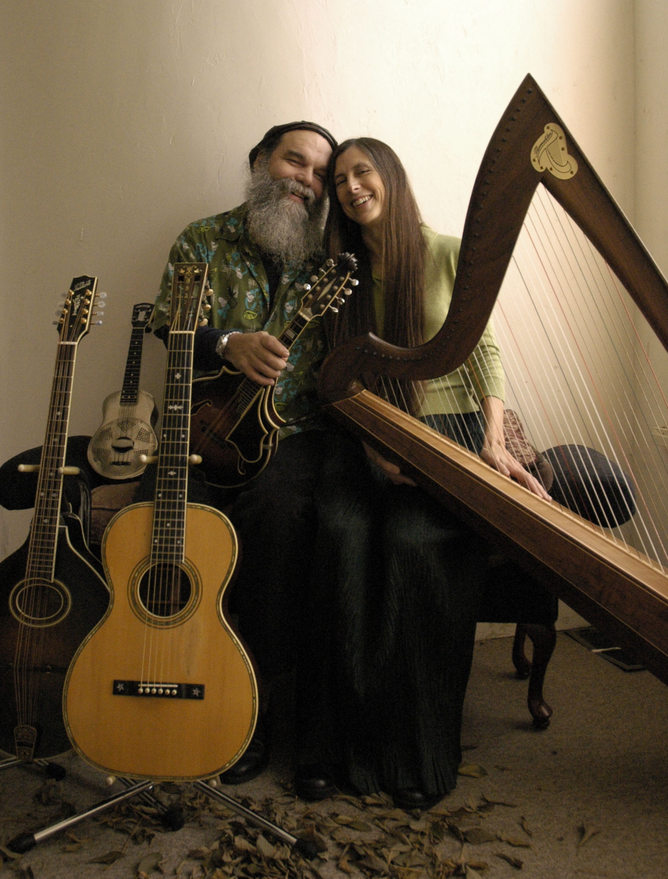

***Curtis & Loretta***

***in concert at:***